Blackout Poetry

Creating a blackout poem involves steps that are all about deconstruction then reconstruction.
Step 1: Scan the page first before reading it completely. Keep an eye out for an anchor word as you scan. An anchor word is one word on the page that stands out to you because it is packed and loaded with meaning and significance. Starting with an anchor word is important because it helps you to imagine possible themes and topics for your poem.
Step 2: Now read the page of text in its entirety. Use a pencil to lightly circle any words that connect to the anchor word and resonate with you. Resonant words might be expressive or evocative, but for whatever reason, these are the words on the page that stick with you. Avoid circling more than three words in a row.
Step 3: List all of the circled words on a separate piece of paper. List the words in the order that they appear on the page of text from top to bottom, left to right. The words you use for the final poem will remain in this order so it doesn’t confuse the reader.
Step 4: Select words, without changing their order on the list, and piece them together to create the lines of a poem. You can eliminate parts of words, especially any endings, if it helps to keep the meaning of the poem clear. Try different possibilities for your poem before selecting the lines for your final poem. If you are stuck during this step, return back to the original page of text. The right word you are searching for could be there waiting for you.
Step 5: Return to the page of text and circle only the words you selected for the final poem. Remember to also erase the circles around any words you will not be using.
Step 6: Add an illustration or design to the page of text that connects to your poem. Be very careful not to draw over the circled words you selected for your final poem!
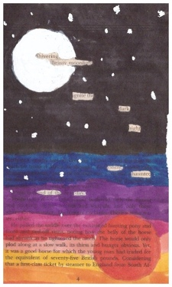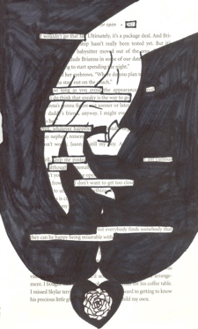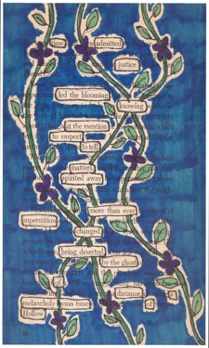Photos courtesy of Stacy Antoville

